
The minutes of the meeting of Satterthwaite Parish Council held in the Parish Room, Satterthwaite on Monday13th July 2026 at 7.30 pm.
Minutes
Item
Opening Administration
1 | Welcome and Introductions  4 members of the community welcomed including Mr. Southworth as lengthsman.  Apologies  None
2 | Declarations of interest  - To receive declarations by elected and co-opted members of disclosable pecuniary interests in respect of items on this agenda  None
3 | Requests for Dispensations  - The clerk to report any requests received since the previous meeting for dispensations to speak and/or vote on any matter where a member has a disclosable pecuniary interest.  None
4 | Minutes  - Chair to review and sign last meetings minutes on 8th June 2026 - agreed as an accurate record and signed.  - Chair to review and authorise AGM minutes from the 8th June 2026 – agreed as an accurate record and signed.
Matters for consideration
5 | Public participation  - To receive comments and representations from members of the public in relation to any item on the agenda  In attendance as noted – no additional matters brought.
6 | Updates on ongoing issues and actions from last meeting  Review of action log  - Playground quotes – 3 companies contacted:  - Flights of Fantasy Teams 1st May - quote received  - Pentagon play face to face 7th May – quote received  - Playdale face to face 4th June – quote awaited – Teams meeting 21st July for final quote  Grant funding can begin as the budget given to all 3 companies is the same. To be discussed at next meeting as to who we will work with and final design.  2. Village Parking – Planning application rejected - complaint re: overall process and lack of transparency sent to LDNPA - no response yet. Clerk to follow up on complaint response. Waiting for planning consultant to respond regarding next steps before further action.  3. Moor lane and motorcyclists - to log all ongoing activity on 101 email/online to keep accurate record of misuse. Was previous discussion regarding ANPR but no further correspondence on further action.
7 | Items for meeting not covered above  - Community emergency plan for village – revisit Parish plan and look at what other communities are doing. Link with Parish Room Committee. Cllr Gary Thomason will follow-up.  - Fine given to Dale Park caravan – to chase plans from LDNPA with second one in area – no evidence of agricultural use noted by local residents – to update planning officers.
8 | Additional or urgent points to raise regarding Parish or Councillor matters  Issues finding quotes to resurface tennis court – rejected 3 times by companies approached so far. Suggestion that we contact the companies who did Coniston Sport and Social Club and Hawkshead playground and see if they will be able to quote for the work. Cllr. Howard Joseph will follow this up.  Concerns regarding anti-social behaviour in the village including abusive and intimidating behaviour which have been reported to the police, and issues re: dog fouling. If behaviour escalates, it has been noted that the Parish Council can raise a civil injunction as a criminal matter. Will continue to monitor.
9 | Items for the Lengthsman  To discuss more streamlined communication and autonomy regarding work required in the parish.  Mr. Southworth has agreed to report any issues needing addressing to the Clerk for reporting as necessary. Council agreed full autonomy to Mr. Southworth to do any work necessary without requiring Council sign off at meetings, to allow more streamlined and efficient timelines. Work required reported by other residents to the Parish Council will be addressed as usual and passed to the lengthsman.
Planning
10 | Planning Consultations sought from Parish Council  - 7/2026/5318: Satterthwaite Parish Room. Refurbishment and extension - variation of condition 2 (plans and details) on planning permission 7/2025/5368 the building requires an intake and extract vent in the roof for air handling unit  Supported – Clerk will respond.  One resident in attendance raised that there has been a proposal to increase the number of The Lodges at Satterthwaite. No formal communication has been sent to Parish Council yet.
Finance
11 | Accounts since last meeting 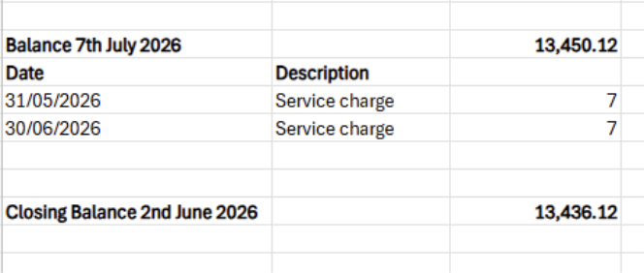  Reconciled accounts and agreed.
12 | Review internal audit report - recognised the comments regarding reconciliation going forward and inaccuracies in 24/25 AGAR. Will be no issues moving forward.
Key correspondence, consultations and reports not covered above
12 | Cumbria Bus Reform Pilot study – closes 20th July 2026  Community support for a bus and from the Parish Council. To respond positively and should fit in with sustainable transport for the area.
13 | ‘have your say’ in shaping the next stage of Westmorland and Furness’ first Local Plan – closes 11th August 2026  Cllr. Thomason to follow-up and send comments to Cllrs and then will respond on behalf of the Parish Council.
Council calendar
 | Agreed to hold a village BBQ 5th Sept 4pm start – emails and advertising nearer time. Clerk to ask Parish Room Committee if they will provide bar and use profits for refurbishment fund.
Closing administration
16 | Agenda items for next meeting  Final decision on playground plan and quotes.
17 | Next meeting date to be agreed  7th Sept 2026 7:30pm  19th October 2026 7:30pm

